**Virtualization in Cloud Computing and Types**

* Virtualization creates virtual versions of resources, enabling multiple operating systems and applications to run simultaneously on the same hardware.
* It optimizes hardware use, reduces costs, and enhances energy efficiency for organizations and cloud providers.
* Virtualization enables sharing of physical resources among multiple users or organizations via logical abstraction.
* It forms the backbone of Infrastructure-as-a-Service (IaaS), providing virtualized environments for computing, storage, and networking.

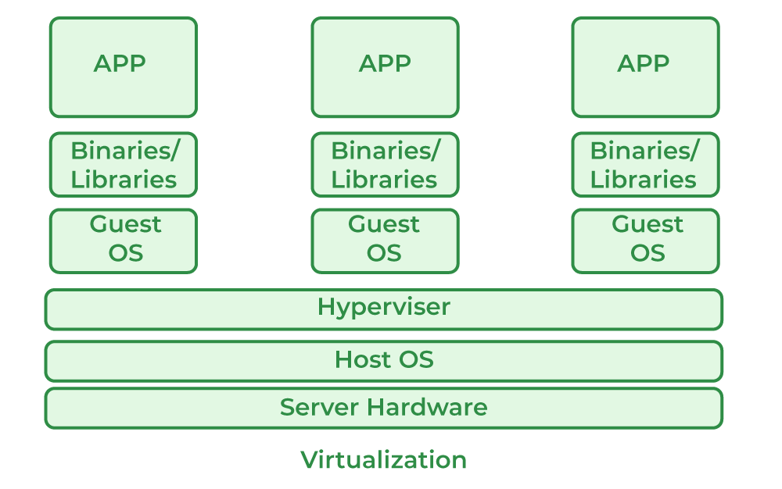

* **Host Machine**:  
  The physical machine on which the virtual machine is created and runs.
* **Guest Machine**:  
  The virtual machine that operates within the host machine's environment.

## Work of Virtualization in Cloud Computing

* Virtualization allows users to share infrastructure resources in the cloud, maximizing utilization and efficiency.
* Cloud vendors (a third-party company)manage physical resources, while users benefit from virtualized environments without needing to maintain hardware.
* Virtualization reduces costs by enabling organizations to use third-party services instead of investing heavily in their own infrastructure.
* Despite the cost of cloud services, virtualization helps offset expenses by optimizing resource use and outsourcing maintenance.
* Virtualization underpins the delivery of scalable, flexible, and efficient cloud services by abstracting physical resources.

## **Types of Virtualization**

* Application Virtualization
* Network Virtualization
* Desktop Virtualization
* 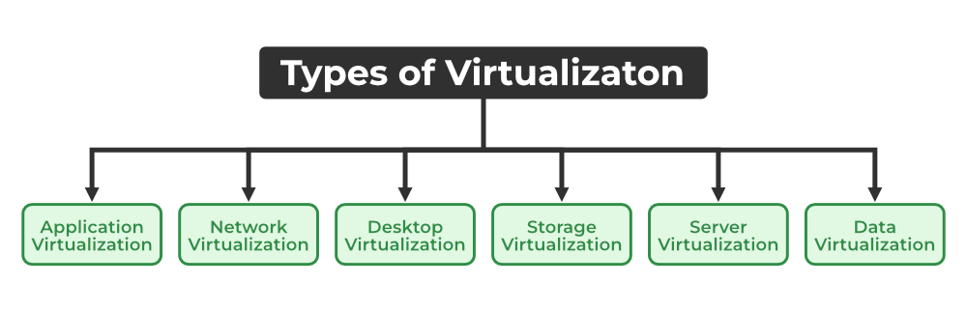Storage Virtualization

**Application Virtualization:**

* Application virtualization enables users to remotely access an application from a server, which stores all personal data and application characteristics.
* The application runs on a local workstation via the internet, allowing scenarios like running multiple versions of the same software.

**Network Virtualization:**

* Network virtualization enables multiple virtual networks to operate on a single physical network, each with separate control and data planes
* These virtual networks can be independently managed by different parties, maintaining confidentiality between them.
* 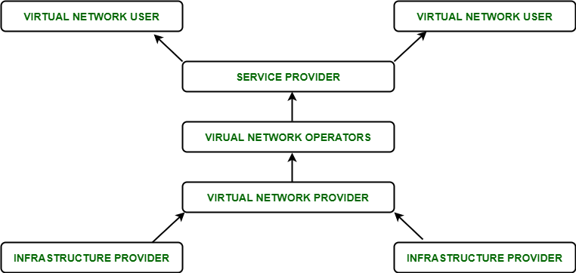It supports creating and provisioning virtual components like switches, routers, firewalls, VPNs, and load balancers quickly, enhancing flexibility and security.

**Desktop Virtualization:**

* Desktop virtualization stores a user's operating system on a remote server, enabling access to their desktop from any device or location.
* It is ideal for users requiring specific operating systems other than the server OS, offering a virtual desktop experience.
* Key advantages include enhanced user mobility, portability, and simplified management of software installation, updates, and patches.

## **Benefits of Virtualization**

* More flexible and efficient allocation of resources.
* Enhance development productivity.
* It lowers the cost of IT infrastructure.
* Remote access and rapid scalability.

## Drawback of Virtualization

* **High Initial Investment**:  
  Cloud adoption requires a high initial investment but helps reduce long-term costs for companies.
* **Learning New Infrastructure**:  
  Transitioning to the cloud requires skilled staff, either through hiring or training existing employees.
* **Risk of Data**:  
  Hosting data on third-party resources increases the risk of potential security breaches or cyberattacks.

## Characteristics of Virtualization

* **Increased Security**:  
  Virtualization provides a secure, controlled execution environment by isolating guest programs from the host system.
* **Managed Execution**:  
  Virtualization facilitates controlled sharing, aggregation, emulation, and isolation of guest and host resources.
* **Sharing**:  
  Virtualization allows creating separate computing environments on the same host, enabling resource sharing.
* **Aggregation**:  
  Virtualization enables the aggregation of multiple physical resources to be shared across several guest environments.

## Uses of Virtualization

* Data-integration
* Business-integration